Open new folder with the name of simple calculator

Run cmd command of that folder

Run command npm init (note package manager ineshalize

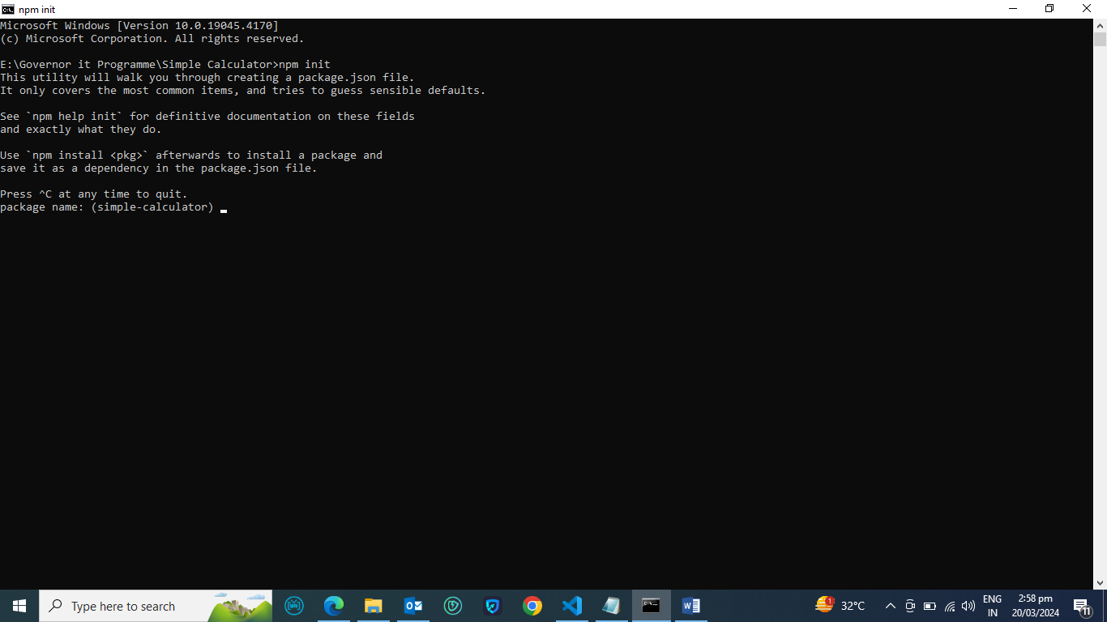

package name: (simple-calculator)

Name by default he lega jo folder name ho (Inter)

version: (1.0.0)

Application version (Inter)

description: A simple Calculator with typescript,node.js and inquirer

App ka description (Inter)

entry point: (index.js)

Main file he entry point hote hai. Jis main sare app related file hote hain

test command:

git repository:

keywords:

author: Majid Ali

license: (ISC) MIT

About to write to E:\Governor it Programme\Simple Calculator\package.json:

{

"name": "simple-calculator",

"version": "1.0.0",

"description": "A simple Calculator with typescript,node.js and inquirer",

"main": "index.js",

"scripts": {

"test": "echo \"Error: no test specified\" && exit 1"

},

"author": "Majid Ali",

"license": "MIT"

}

Is this OK? (yes)

E:\Governor it Programme\Simple Calculator>

Open same file in vs code (code .)

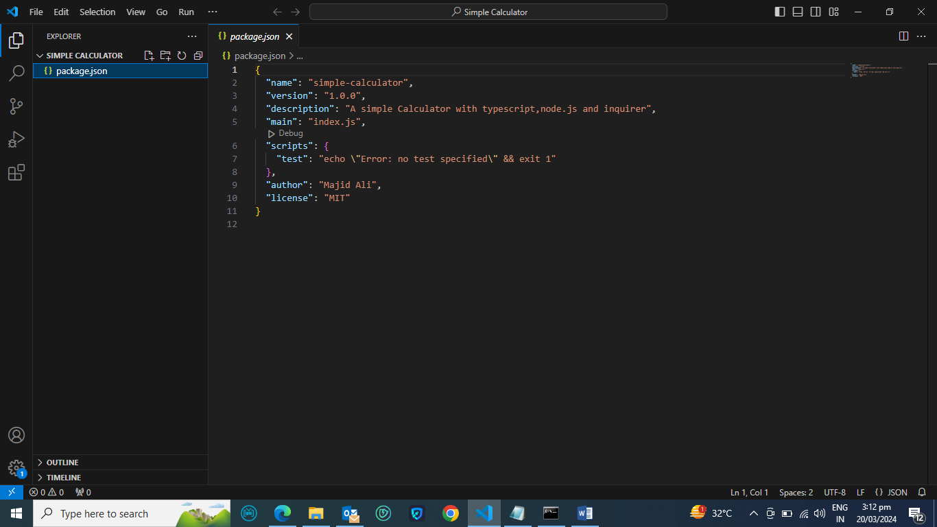

E:\Governor it Programme\Simple Calculator>code .

Add type script in the vs code (tsc –init)

E:\Governor it Programme\Simple Calculator>tsc --init

Created a new tsconfig.json with:

TS

target: es2016

module: commonjs

strict: true

esModuleInterop: true

skipLibCheck: true

forceConsistentCasingInFileNames: true

You can learn more at <https://aka.ms/tsconfig>

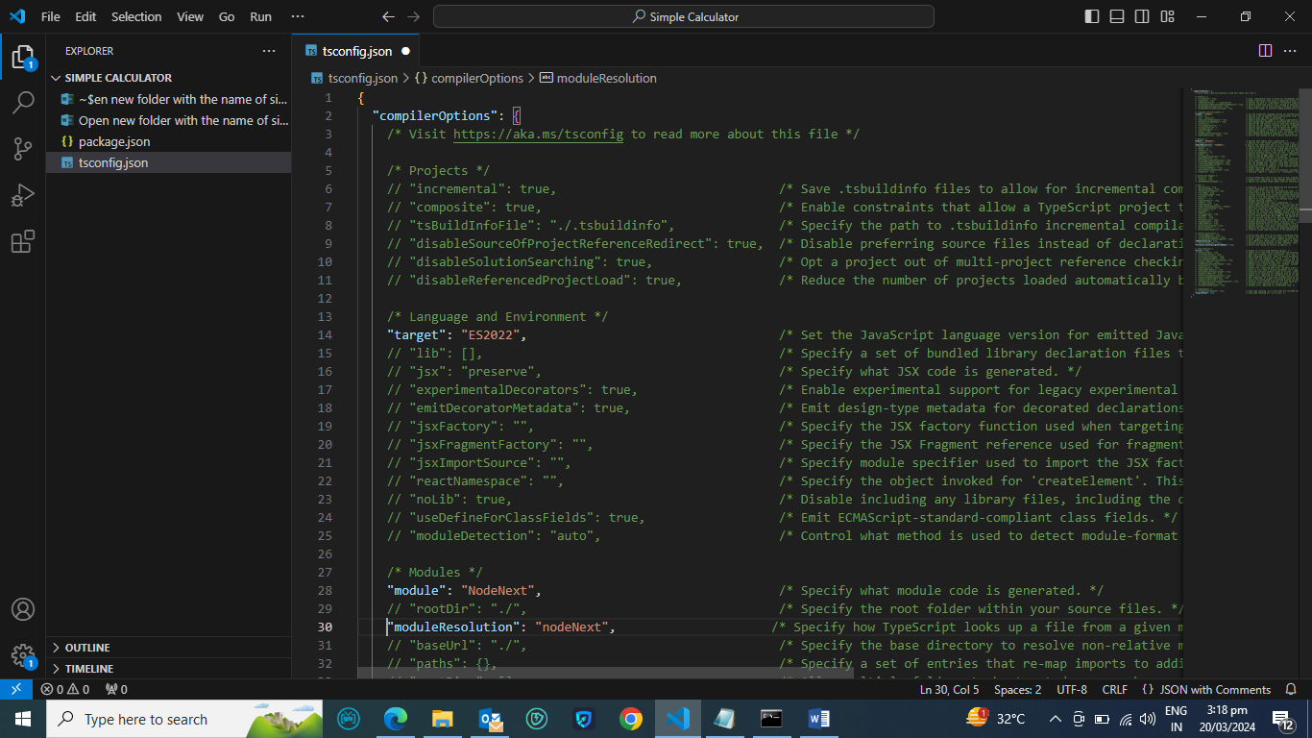

Make 3 changes in tsconfig.json

 1-"target": "ES2022",

2-module "module": "NodeNext",

"moduleResolution": "nodeNext",

Add  "type":"module",

After index.js

"main": "index.js",

  "type":"module",

Now make a new file click on the file name and ad new file “index.ts”

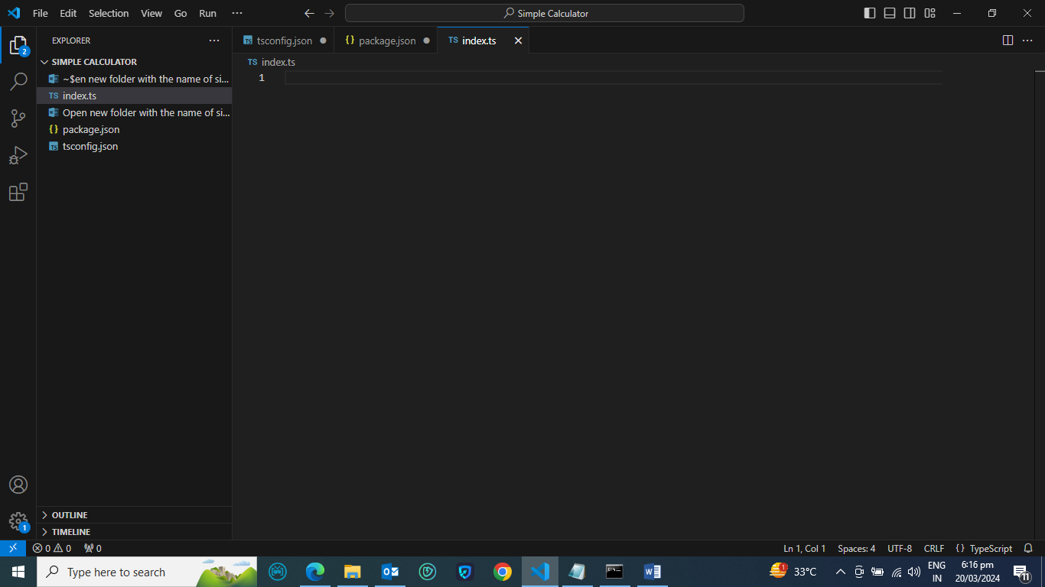

Run this command

npm i inquirer

on cmd file

write code import inquirer from "inquirer";

in index.ts file.

Go to cmd and run the command

npm i --save-dev @types/inquirer`

it seams in vs code

